Digital Training

Digital Champion
Volunteer Handbook

Contents
Welcome to the team 4
About [Organisation name] 4
Information and resources 4
[Organisation name] Digital Training 5
Aims of digital training 5
Strategy for digital training 5
Why digital training is necessary 5
The negative impact of a lack of digital access 5
What to Expect 6
We will 6
We ask that you will 6
Getting Started 7
Settling in, support and development 7
Induction 7
DBS and ID check 7
Ongoing support 7
Learning and development 7
Policies 8
Safeguarding 8
If you have a non-urgent safeguarding concern 8
Confidentiality 9
Data protection 9
Equity, diversity and inclusion 9
Social media 9
Health and safety 10
Risk assessment 10
Fire 10
First aid 10
Lone working 10
Key Information 11
Insurance 11
Travel to venues 11
Car drivers 11
Volunteer expenses 11
Ending the volunteer placement 11
Important Contact Information 12
Staying connected 12
References 13
Dealing with Problems 13
Finally… 15

Welcome to the team
- Provide an introduction here.
Giving your time and energy as a Digital Champion is truly going to change people’s lives for the better.
Whatever your reason for deciding to volunteer, we want to make sure that you enjoy your time with us and that you know just how much we value your support.
This handbook will help get you started. It contains the important things you need to know and details of where you can find further information and support. Please read through it before you start volunteering and please speak to a member of staff if you have any questions.
Thank you for joining us.

About [Organisation name]
- Provide information about your organisation here.
You will know something about [Organisation name] already, but you can read more about us on our website, and we encourage you to read our newsletters and blog posts, and follow us on social media:
Facebook:
LinkedIn:

Information and resources
- Provide:
Contact details for Digital Training staff members
Location of policies referred to in this handbook.

[Organisation name] Digital Training

Aims of digital training
[Organisation name] Digital Training exists to help people overcome barriers that prevent them from accessing services and opportunities that are available online.

Strategy for digital training
- Provide information here about how your digital training is delivered.

Why digital training is necessary
In an increasingly digital age, those who are not engaging effectively with the digital world are at risk of being left behind. Technological change means that digital skills are increasingly important for connecting with others, accessing information and services, and meeting the changing demands of the workplace and economy. This has created a digital divide between those who have access to information and communication technology and those who do not, giving rise to inequalities in access to opportunities, knowledge, services, and goods.

The negative impact of a lack of digital access
- poorer health outcomes and lower life expectancy
- increased loneliness and social isolation
- reduced access to jobs and education
- paying more for essentials
- increased risk of falling into poverty
- lack of a voice and visibility in the modern world

We need to remember that not everyone is going at our pace…
That’s why we need Digital Champions like you!

What to Expect
We will  - Provide clear expectations of your tasks and responsibilities.  - Give you an induction to your role and opportunities for further training.  - Ensure you are in a safe environment and are covered by our liability insurance.  - Provide the equipment needed.  - Treat you with respect and dignity.  - Avoid making unfair demands on your time.  - Ensure a member of staff checks in with you regularly.  - Keep you informed.  - Listen to and consider your suggestions.  - Resolve issues quickly and fairly.  - Provide you with feedback if there are any concerns relating to your performance or behaviour.  - Recognise your contributions and celebrate your achievements.  - Keep your personal information confidential. | We ask that you will  - Accept and embrace [Organisation name]’s aims, objectives and policies.  - Know what is expected in your role and speak to a staff member if you’re not sure about anything.  - Take care of your own health and safety and that of those you interact with.  - Treat others with respect and dignity and keep their information confidential.  - Raise any concerns you have with a member of staff and let them know if you need any extra support.  - Be reliable and keep us informed if you can’t attend a session, or if you need to take a break from volunteering, giving as much notice as possible.  - Make us aware if you feel that there may be a conflict of interest between your volunteering and other commitments.  - Carry out your role to the best of your ability and undertake any training as required.

Getting Started

Settling in, support and development
- Provide information here about what your new DC can expect as they get started.

Induction
There can be a lot to get your head around when you start something new, and volunteering is no different. By now you will already have completed your Digital Champion Induction Training, however if you need a refresher about anything that was covered in the session, please don’t hesitate to ask.
When you applied for this role, you will have read the Digital Champion Role Description, which briefly outlines what you will be doing. This is also clarified in the Participation Agreement you will sign.

DBS and ID check
Following your Digital Champion training, you will be sent an email inviting you to complete a DBS form. You can only begin working with clients once [your DBS Certificate has been issued and viewed, so please inform your named staff member as soon as you receive it.]
You will then be issued with an ID badge, which must be worn whenever you are volunteering on behalf of [Organisation name].

Ongoing support
You will be working alongside a [Organisation name] staff member, usually a Digital Skills Tutor. Within a Digital Training Group session, that staff member is the first person to speak to about any questions you have about how to undertake your role in that context.
Other members of staff are available to support you. Please don’t hesitate to make contact should you have any concerns, any ideas or suggestions about your role or just need to chat something though! Staff will also check in with you regularly.
We also organise get togethers so you can receive support from and socialise with your fellow volunteers, and get any new information or training as required.

Learning and development
Staff members may send you further training opportunities and information of interest relevant to your Digital Champion role. We also encourage you to share any helpful resources with your fellow volunteers by sending them to a member of staff to distribute.

Policies
Below are summaries of [Organisation name]’s Polices We require that you read each of the Polices in full and familiarise yourself with them before signing the Volunteer Agreement.

Safeguarding
Safeguarding means protecting people’s health, wellbeing and human rights, and supporting them to live free from harm, abuse and neglect. As a volunteer you have a duty to be mindful and alert about any possible safeguarding issues when working with clients. If in any doubt discuss this with a member of staff.
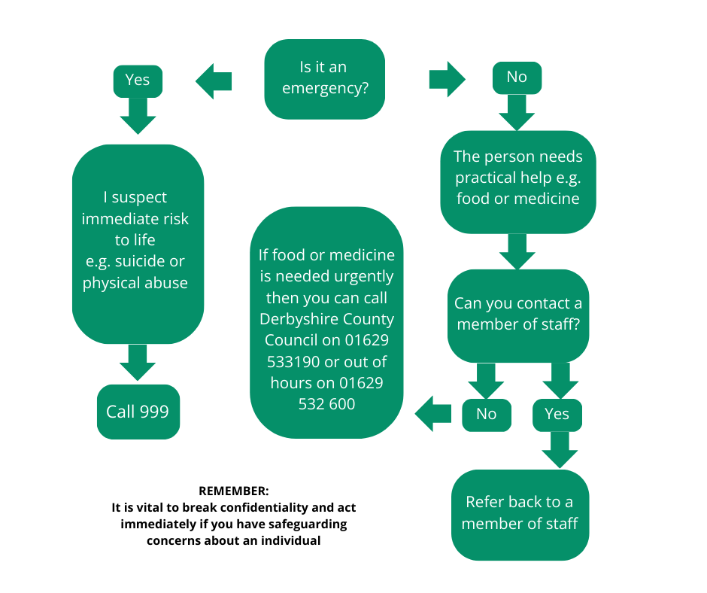

If you have a non-urgent safeguarding concern
For example, a concern about a member of [Organisation name] staff or a [Organisation name] volunteer:
- Contact [Organisation name’s person in authority]:
- If your concern relates to the [person in authority], then contact [their Line Manager] [provide contact details]:
- If your concern relates to the charity as a whole, then contact Derbyshire County Council Adult Services on 01629 533190
Please read the full Safeguarding Policy.

Confidentiality
In your role you will become party to people’s personal and confidential information – email addresses, passwords, etc. It is essential that this information remains confidential and is not disclosed to anyone outside of [Organisation name], unless there is a legal duty for you to do so, such as a safeguarding concern. If you are asked for someone’s details, then refer the enquirer to a [Organisation name] staff member.
Please read the full Confidentiality Policy.

Data protection
[Organisation name] will hold contact details and other personal information for all volunteers and clients. In line with our Data Protection Policy, records will not be held for longer than necessary and will be stored and disposed of securely. You can request to see the information that we hold about you.
Please read the full Data Protection Policy.

Equity, diversity and inclusion
[Organisation name] is committed to providing a working environment where all employees and volunteers are treated with dignity and respect and are valued for the different skills and abilities they bring to the workplace.
We are committed to a policy of treating all employees, volunteers and clients equally and fairly. We will not discriminate against any person because of their age, disability, ethnic origin, gender, marital status, nationality, political beliefs, race, religion, sexual orientation or socio-economic background.
[Organisation name] celebrates the diversity of all the communities it serves, values the contribution made by all and will treat everyone in an open and equal way.
However, there are some contexts, such as women’s-only groups that are occasionally necessary to enable participation of some sections of society. Where such groups exist, we also strive to ensure that other people are not excluded from the opportunity of support.
Please read the full Equity, Diversity and Inclusion Policy.

Social media
Some volunteers may choose to support the charity’s work using their personal social media accounts. While social media brings the charity to a wide audience, it can also present risks. The purpose of our policy is to ensure that volunteers using social media represent and reflect [Organisation name] in the best way possible. It is also important to mitigate risks (such as reputational or legal issues) associated with the use of social media to protect our supporters, clients, staff and volunteers.
Please read the full Social Media Policy.

Health and safety
[Organisation name] aims to anticipate risks and, wherever practicable, to remove or reduce potential hazards to the volunteer and the client they are supporting.

Risk assessment
You should familiarise yourself with health and safety issues that are specific to your venue, and this will form part of your induction. Make sure you are familiar with the risk assessment for the venues in which you volunteer and abide by the procedures they contain to mitigate any risks.
Volunteers are asked to be mindful of taking reasonable care for their own safety and that of clients, including being vigilant to prevent accidents. Always inform the staff member present or another staff member of any incidents or accidents as soon as possible.

Fire
You should familiarise yourself with the fire evacuation procedures for the venue where you are volunteering, and this will form part of your induction.

First aid
In case of emergency, please make yourself aware of your first aid point of contact at the venue where you are volunteering. Please report any accidents or near misses that you experience while volunteering.

Lone working
You will not be left alone whilst volunteering and there will usually be a staff member present. If you do have any concerns, please speak to any member of staff.
Please read the full Health and Safety Policy.

Key Information

Insurance
[Organisation name] provides employer’s liability and public liability insurance for volunteers whilst undertaking voluntary activities. Volunteers must register with [Organisation name] to be covered by this insurance you will do this by signing the Volunteer Agreement.

Travel to venues
We will try to arrange for you to work as close to your home as possible in order to minimise travel to the place where you volunteer. If you travel by public transport, we will aim to ensure that your venues are as close to easy routes as possible.

Car drivers
If your role involves using your car you must inform your insurance provider that you are using your vehicle to volunteer. Most insurance companies agree to cover volunteer car journeys at no extra charge, however, please check this with your own insurance company.
Please do not give lifts to clients.

Volunteer expenses
[Organisation name] will reimburse any agreed reasonable travel costs associated with your volunteering role. All expenses should be discussed with a member of staff before making a claim. If claimed, expenses will be reimbursed on a monthly basis.

Ending the volunteer placement
Volunteer placements can be ended at any time by either party. If you decide that you are unable to continue to volunteer, we ask that you let a member of staff know this and that you complete an evaluation form of your experience of working with [Organisation name].

Important Contact Information
Your main point of contact is the member of staff running the training group at which you volunteer.
We will ensure that we stay in regular contact with you during your volunteering, by text message, phone call or email, and you can also contact us at any time.

Staying connected
If any of your contact details change, then please inform a member of staff as soon as possible.

References
Before welcoming you as a Digital Champion we will request references for you.
If you want any [Organisation name] staff to act as a referee on your behalf, please inform that member of staff first. We will write confidential and fair references, including only positive and accurate statements about you. We will give you the opportunity to see and discuss your reference before we send it.

Dealing with Problems
We very much value your contribution and want to ensure that your time volunteering with [Organisation name] is a positive one. We ask you to help us to ensure it is a good experience for everyone.
Problem Solving Procedure
Introduction
This procedure is in place to ensure that volunteers and those supervising or supporting them are aware of the type of problems that may arise during the volunteering placement and steps that will be taken to resolve these problems.
Problems will vary in terms of seriousness and the steps taken to resolve them will vary accordingly.
Examples of problems that may arise:
- volunteers struggling to do what the role asks
- volunteers doing too much and feeling overwhelmed
- difficult behaviour, such as not getting on with others
- unreliability, such as failure to inform their supervisor if they are unable to volunteer
- volunteers being unhappy with things the organisation is doing or not doing.
- bullying or harassment
- behaviour contrary to the charity’s Equity, Diversity and Inclusivity policy
- sharing confidential data
- fraud or stealing funds
- being under the influence of alcohol or drugs.
Please note, these are examples of problems that may arise, and this is not a complete list.
Responsibility for dealing with problems and complaints
You will be under direct supervision of a named member of staff. In the first instance that member of staff, when made aware of the problem, will follow the process outlined below. In some instances, it may be appropriate to signpost you to the [Organisation name] Complaints Policy, a copy of which is available in the Digital Champions area of our website.
It may be appropriate, dependent on the seriousness of the problem, to refer the issue to a member of the senior management team.
Problem solving process
The aim will always be to resolve the problem together to reach a solution.
- Fact finding, this will involve speaking to the you and anyone else affected.
- Discussion with you about what the problem is and the impact it has had.
- Consideration of what you would like to happen next.
- Consideration of possible solutions (see below).
- Agreement regarding next steps and a review timetable.
Possible solutions
- If necessary, your role and its expectations will be re-explained. A reminder of the role, its boundaries and what we expect from you.
- The offer of more support or training.
- A change of tasks. If a task is causing an issue, we will see if someone else could do it or if you could do it in another way. Other resources may also help.
If the problem continues
It may be that the problem doesn’t resolve immediately, in which case the issue will be discussed again and further steps agreed on, potentially with the involvement of the senior management team.
If necessary, a volunteer may wish to follow the procedure in our Complaints Policy.
In some circumstances it may be necessary to end the volunteering placement (see below).
Ending a volunteer placement
There may be a variety of reasons why a placement ends, for example the service is no longer provided. In some cases, it may be because a problem has not been resolved. This could be due to a serious breach of conduct.
We will ensure that:
- We have followed the problem-solving process
- We schedule a time and place to meet with you, giving you enough notice
- We choose a private, appropriate location to meet
- We offer you the chance to have somebody with you if you would like
- We explain to you that you’re being asked to leave and why
- We thank you for your contribution
- We follow it up in writing if requested.

Finally…
Thank you so very much for becoming a Digital Champion Volunteer.
You truly are going to change lives for the better!

