Safeguarding process template
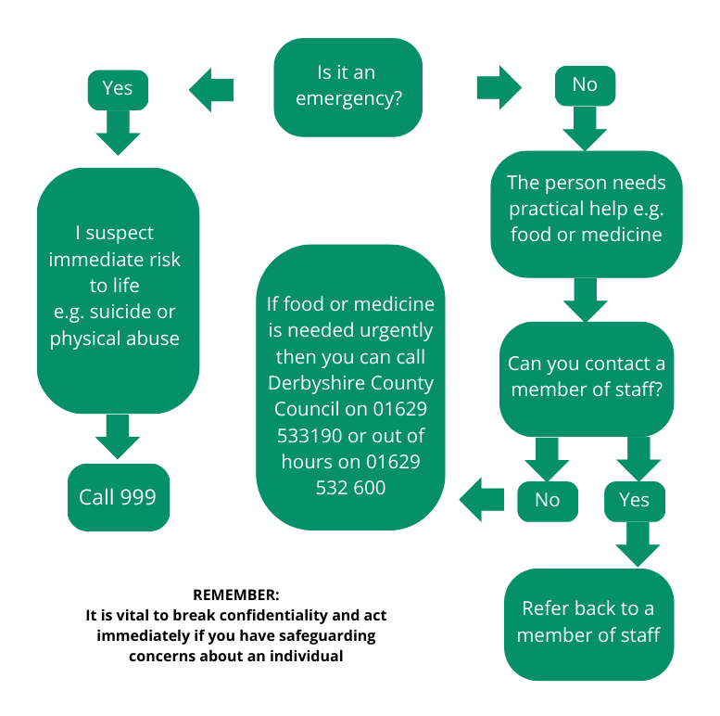
Safeguarding means protecting people’s health, wellbeing and human rights, and supporting them to live free from harm, abuse and neglect. As a volunteer you have a duty to be mindful and alert about any possible safeguarding issues when working with clients. If in any doubt discuss this with a member of staff.

Non-urgent safeguarding concerns:
About a member of [Organisation Name] staff or a [Organisation Name] volunteer:
Contact [Organisation’s person in authority] [provide contact details].
If your concern relates to the [person in authority], then contact their [Line Manager]: [provide contact details].
If your concern relates to the charity as a whole, then contact Derbyshire County Council Adult Services on 01629 533190
Please read the full Safeguarding Policy.

